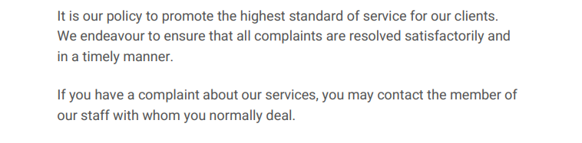
Jessica Tingey-Emptage
RMK Insurance Consultants (PART OF THE BROWN & BROWN TEAM)
Lake Meadows Business Park, 13 Woodbrook Crescent,
Billericay, Essex, CM12 0EQ

Tel: 01277 633166 Email: jemptage@LDSAssociates.co.uk

